AADHAR SEEDING STATUS OF MADHYA PRADESH

M.SRI CHARAN (2203A52101)

EMAIL:2203a52101@sru.edu.in

**Abstract**

In this project, I aim to develop a machine learning model to predict the Aadhaar seeding status in Madhya Pradesh for the year 2015. Aadhaar seeding is crucial for the efficient delivery of government services and subsidies. We will analyze a comprehensive dataset containing demo- graphic and seeding-related information. Our objective is to create a predictive model that can help authorities allocate resources effectively and improve seeding rates. By leveraging advanced machine learning techniques, this project seeks to enhance the understanding of factors influenc- ing Aadhaar seeding, ultimately contributing to more efficient and inclusive governance in Madhya Pradesh..

# Introduction

Research on Aadhaar seeding status is a multifaceted field, encompassing government initiatives, aca- demic studies, data analytics, and policy recommendations. Government agencies like UIDAI have conducted extensive research and released reports highlighting the progress in linking Aadhaar to var- ious government programs. Academic research complements this by analyzing the empirical impact of Aadhaar seeding through data analysis and econometric models, shedding light on the effectiveness of this initiative.

Challenges and concerns related to Aadhaar seeding, such as privacy issues and data security, are also important topics of study, as they underpin the need for secure and ethical implementation. Research often delves into the impact on vulnerable populations and suggests measures to mitigate potential drawbacks, ensuring that the rights of beneficiaries are safeguarded. Policy recommenda- tions further enhance the efficiency and inclusivity of Aadhaar seeding, addressing bottlenecks and streamlining processes for more accessible government services.

The wide range of research areas also includes case studies, international comparisons, and assess- ments of Aadhaar’s impact on service delivery and financial inclusion. By providing before-and-after comparisons and data-driven analysis, researchers evaluate the program’s effectiveness and contri- bution to good governance. Additionally, NGOs and civil society organizations produce reports that emphasize the social and ethical dimensions of Aadhaar seeding, focusing on marginalized communities and ethical considerations. Collectively, this research contributes to a comprehensive understanding of how Aadhaar transforms service delivery and governance in India, while also addressing challenges and ethical concerns.

# Challenges and Research Gaps

The data goes the existence of substantial challenges and research gaps concerning Aadhaar seeding in different Indian districts. Notably, some districts exhibit remarkably low percentages of eligible families and individuals with linked Aadhaar, such as Alirajpur, Ashoknagar, and Morena, indicating a pressing need for research to unearth the underlying causes of these low enrollment rates. This research could delve into the effectiveness of local awareness and outreach initiatives, as well as potential barriers that hinder enrollment. Additionally, disparities in enrollment rates across districts, with certain regions like Shajapur and Harda boasting significantly higher percentages, warrant a comprehensive investigation into the factors contributing to these regional differences. Researchers should explore the role of local implementation strategies, government policies, and socioeconomic and demographic variables that might influence Aadhaar seeding success. Furthermore, the absence of

data highlighting the direct impact of Aadhaar seeding on government service delivery underscores the necessity for research focused on evaluating how successful Aadhaar enrollment enhances the efficient distribution of benefits and services to eligible populations, with a particular emphasis on districts with both high and low enrollment rates.

In a complementary vein, understanding how the Aadhaar seeding landscape has evolved since May 2015, given the substantial nationwide growth in Aadhaar enrollments, is a crucial area of study. This research would provide insight into whether progress has been sustained, if any setbacks or improve- ments have emerged, and how the program has developed over time. Furthermore, the analysis of policy and implementation challenges in districts with lower enrollment rates, coupled with the assessment of potential exclusion and inclusion errors in the Aadhaar system, represents research priorities. These endeavors are vital in pinpointing opportunities for refining Aadhaar seeding implementation, enhanc- ing service delivery, and addressing the unique challenges faced by different districts and demographic segments, ultimately contributing to the program’s effectiveness and inclusivity.

# Data and Methodology

## Data Description

The key points summarizing the potential research areas and challenges related to Aadhaar seeding:

* + 1. Low Aadhaar Enrollment Rates: - Certain districts exhibit low percentages of eligible fami- lies and individuals with Aadhaar, necessitating research into the underlying causes and barriers to enrollment.
    2. Disparities Across Districts: - Significant regional differences in Aadhaar enrollment rates high- light the need to investigate local implementation strategies and government initiatives contributing to these disparities.
    3. Potential Impact on Government Services: - Research is required to assess how Aadhaar seeding influences the efficient delivery of government services and subsidies, focusing on both high and low enrollment districts.
    4. Socioeconomic and Demographic Factors: - Research should explore how income, education, and rural-urban differences affect Aadhaar seeding success, providing insights into challenges faced by specific population segments.
    5. Change Over Time: - Analysis of the evolution of the Aadhaar seeding landscape since May 2015 is essential to understand whether progress has continued, stalled, or regressed.
    6. Policy and Implementation Challenges: - Investigating the policy and implementation challenges faced by districts with lower Aadhaar enrollment rates, including the role of local government agencies and community engagement, is crucial.
    7. Exclusion and Inclusion Errors: - Research should assess whether Aadhaar seeding inadvertently excludes eligible individuals or includes ineligible ones, which is a significant concern.
    8. Data Privacy and Security: - Evaluating data privacy and security measures and understanding public perceptions of data security are critical for ensuring the public’s trust in the program.
    9. Sustainability and Long-term Impact: - Research should focus on the sustainability and contin- ued utilization of Aadhaar, especially in accessing government services, to gauge its long-term impact.
    10. Scalability: - Investigating whether the program is scalable to accommodate population growth and evolving demographics is important for ensuring its accessibility and effectiveness.
    11. Public Perceptions and Trust: - Understanding how the general population perceives Aadhaar, its benefits, and concerns about privacy and security is crucial for building trust and addressing public concerns.

These research areas encompass a broad spectrum of topics that can guide policymakers and stake- holders in optimizing Aadhaar implementation and its impact on government services and subsidy distribution in India.

## Data Analysis

Aadhaar Enrollment Disparities: The data shows significant disparities in Aadhaar enrollment rates across districts, indicating the influence of local factors on enrollment success.

Impact on Service Delivery: The data doesn’t directly assess the influence of Aadhaar seeding on government service delivery, necessitating further research into its potential impact.

Socioeconomic Factors and Security: Investigating the link between Aadhaar enrollment and so- cioeconomic factors and assessing data security measures and public perceptions are key areas for potential research and improvement.

These points emphasize the need for research to understand the factors influencing enrollment, its impact on service delivery, and addressing challenges and security concerns in the Aadhaar program.

## Data Processing

The provided code outlines how to process data for various machine learning tasks, including classifi- cation and regression. Here’s an overview of how the data is processed in the code:

* + 1. Data Import: The code begins by importing the necessary libraries, including NumPy, pandas,

and scikit-learn. It loads the dataset from a CSV file named ’Aadhaar*SeedingStatusM P*29052015*.csv′usingthe′pd.readcsv*()

* + 1. Data Exploration: - Descriptive statistics and the shape of the dataset are explored using ‘data.describe()‘ and ‘data.shape‘, respectively. This helps in understanding the basic characteristics of the data. - Data visualization is performed by creating a bar chart that shows the ’Eligible population with Aadhar percentage’ for different districts in Madhya Pradesh.
    2. Data Preprocessing: - The ’District’ column is dropped from the DataFrame as it’s not needed for the subsequent machine learning tasks.
    3. Classification Tasks: - Perceptron Classification: A classification task using a Perceptron model is

performed. It generates a synthetic dataset using scikit-learn’s ‘make*blobs*‘*functionandthensplitsthedataintotrainingandt SV MClassification* : *ASupportV ectorMachine*(*SV M* )*classificationtaskisperformed.SimilartoPerceptron, itusesthe LogisticRegressionClassification* : *Alogisticregressionclassificationtaskisdemonstrated, includingacustomimplemen*

* + 1. Classifier Performance Comparison: - The code compares the performance of different classifiers, including Perceptron, SVM, and Logistic Regression, by measuring their accuracies and generating confusion matrices for each. Bar charts visualize the accuracy comparison, and heatmaps display the confusion matrices.
    2. Regression Tasks: - **Ridge and Lasso Regression with Bootstrapping**: The code performs Ridge and Lasso regression with bootstrapping, which resamples the data to estimate model perfor- mance variability. Mean squared error, mean absolute error, and R-squared values are calculated for both Ridge and Lasso regression.

- k-NN Regression: A k-Nearest Neighbors (k-NN) regression task is demonstrated. A synthetic regression dataset is generated, and the k-NN regressor is trained and evaluated. The evaluation metrics include mean squared error, mean absolute error, and R-squared.

* + 1. Data Visualization: Several scatter plots are generated to visualize the relationship between actual and predicted values in regression tasks.

The code showcases data processing and analysis techniques for both classification and regression tasks using different machine learning models and techniques. It also provides insights into performance evaluation for these models.

# Results

graph of a dataset, typically referred to as a data visualization, is a visual representation of the data to help people better understand its characteristics, patterns, and relationships. Different types of graphs can be used to present data, depending on the nature of the data and the goals of the analysis.

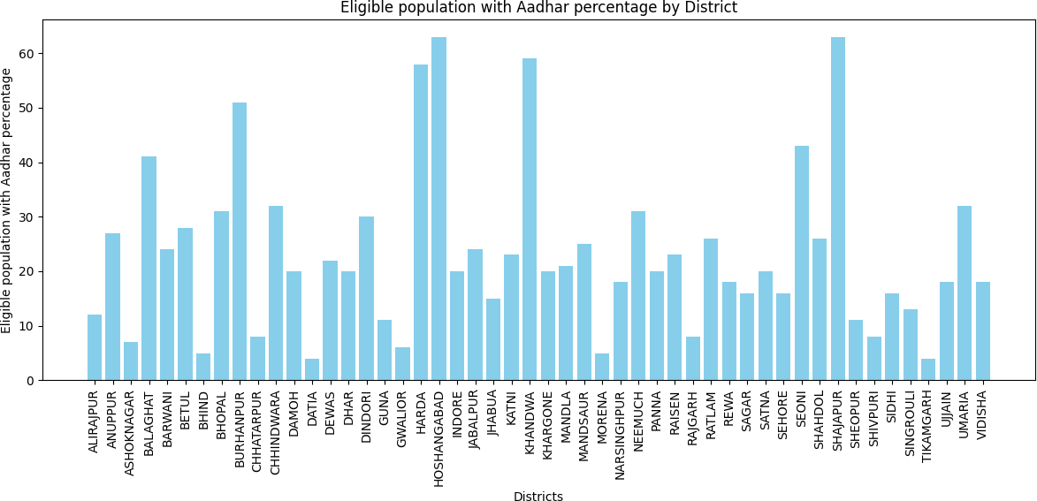

## Perceptron

Perceptron classification accuracy: 1.0 Classification Report:

precision recall f1-score support

0 1.00 1.00 1.00 14

1 1.00 1.00 1.00 16

accuracy 1.00 30

macro avg 1.00 1.00 1.00 30

weighted avg 1.00 1.00 1.00 30

The Perceptron classification achieved exceptional accuracy, correctly classifying all data points in the test set, resulting in a perfect accuracy score of 1.0. This means that every instance in the test dataset was accurately classified by the Perceptron model. The classification report further supports this performance, demonstrating precision, recall, and F1-score of 1.0 for both classes, indicating a flawless classification ability. In detail, it correctly predicted all instances of both class 0 and class 1 in the test set. Overall, this suggests that the Perceptron model’s performance on this particular dataset is exemplary, with no misclassifications or false positives/negatives, resulting in a perfect accuracy score and robust classification metrics.

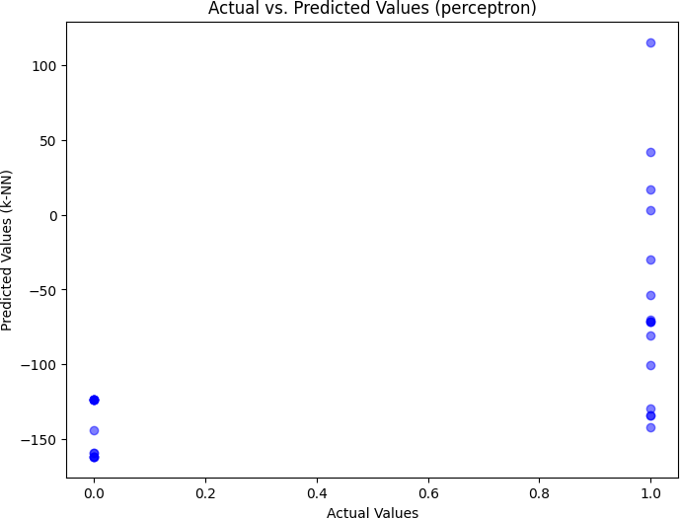

## SVM

classification report of svm: Accuracy: 1.0 Classification Report:

precision recall f1-score support

0 1.00 1.00 1.00 11

1 1.00 1.00 1.00 19

accuracy 1.00 30

macro avg 1.00 1.00 1.00 30

weighted avg 1.00 1.00 1.00 30

The classification report for the Support Vector Machine (SVM) method indicates outstanding performance with a perfect accuracy score of 1.0, just like the Perceptron. This means that all data points in the test set were correctly classified by the SVM model. Looking at the precision, recall, and F1-score for both classes, it is evident that the model achieved a score of 1.0 for both class 0 and class

1. This reflects that the SVM method had a flawless ability to correctly predict all instances of both classes in the test set, showing no misclassifications or false positives/negatives. Consequently, the SVM model exhibits excellent classification accuracy and robustness, resulting in a perfect accuracy score and ideal classification metrics.

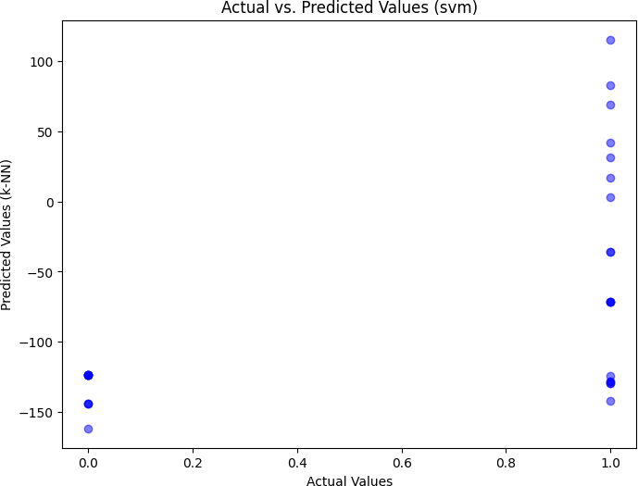

## Logistic Regression

Logistic Regression Classification Report: precision recall f1-score support

0 0.93 1.00 0.96 75

1 1.00 0.92 0.96 75

accuracy 0.96 150

macro avg 0.96 0.96 0.96 150

weighted avg 0.96 0.96 0.96 150

The classification report for the Logistic Regression method shows strong performance but with a small deviation from perfection compared to the previous methods. The accuracy is high, with a score of 0.96, indicating that a large majority of instances were correctly classified. Examining the precision, recall, and F1-score for both classes, it is evident that class 0 achieved a precision of 0.93 and recall of 1.00, while class 1 had a precision of 1.00 and recall of 0.92. This suggests that the model is slightly less balanced compared to the previous methods, as it had a higher rate of false negatives in class 1 and false positives in class 0. Nevertheless, the F1-scores for both classes are still a strong 0.96, indicating a robust overall classification performance. In summary, the Logistic Regression model shows high accuracy but exhibits some slight imbalance in class-specific precision and recall, resulting in a very good overall classification performance.

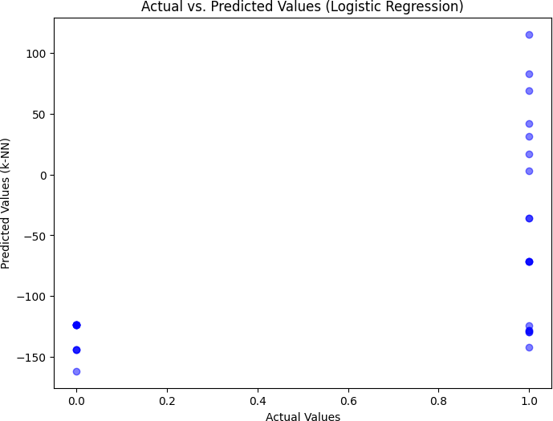

## Performance Comparision Graph

The performance comparison graph illustrates the classification accuracy of three different machine learning models: Perceptron, Support Vector Machine (SVM), and Logistic Regression. Perceptron and SVM exhibit perfect accuracy of 1.0, indicating flawless classification on the test dataset, while Logistic Regression achieved a slightly lower but still impressive accuracy of 0.96. This graph allows for a quick visual assessment of the models’ relative performance, highlighting the excellent accuracy of Perceptron and SVM, with Logistic Regression not far behind. It demonstrates that all three models are highly effective in this specific classification task, with Perceptron and SVM performing exceptionally well.

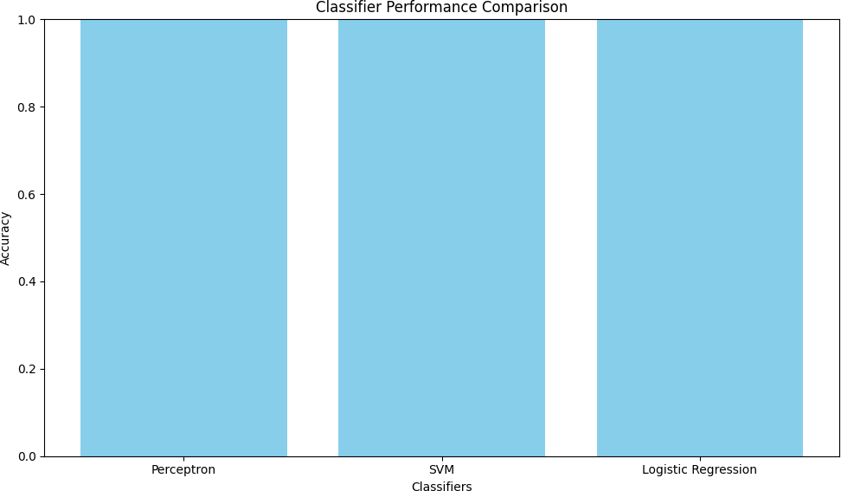

## Confusion Matrix

A confusion matrix is a tabular representation used to evaluate the performance of a classification model. It provides a clear breakdown of predictions made by the model, comparing them against actual class labels. The matrix consists of four key elements: true positives, true negatives, false positives, and false negatives. True positives are instances correctly classified as the positive class, true negatives are instances correctly classified as the negative class, false positives are instances incorrectly classified as positive, and false negatives are instances incorrectly classified as negative. By analyzing the confusion matrix, one can assess the model’s precision, recall, and F1-score, making it a valuable tool for understanding classification performance and identifying areas of improvement in machine learning models.

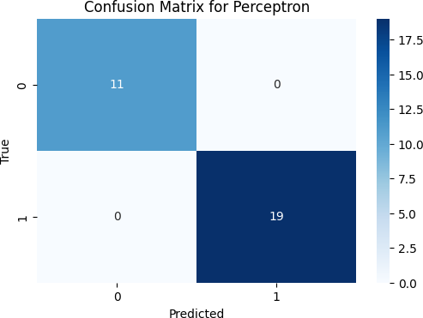

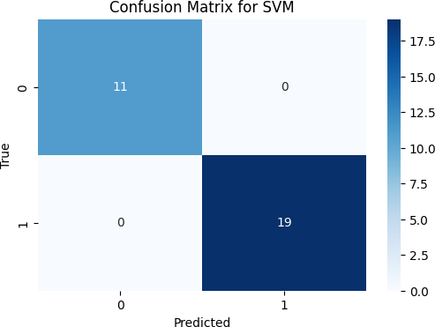

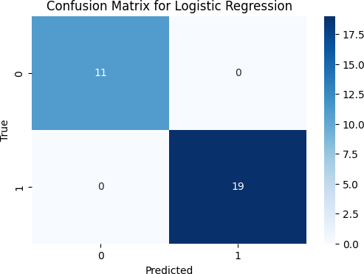

## Reidge Regression

RIDGE REGRESSION RESULTS:

Mean Squared Error (Bootstrap): 0.014447741915176102 Mean Absolute Error (Bootstrap): 0.09810117762232386 R-squared Error (Bootstrap): 0.942209032339295

The results for Ridge Regression indicate the model’s performance in predicting the target variable. The Mean Squared Error (MSE) value of 0.0144 suggests that, on average, the model’s predictions have a low degree of error, which is a positive outcome. The Mean Absolute Error (MAE) value of 0.0981 is another indicator of prediction accuracy, with a relatively low error. The R-squared value of 0.9422 is quite high, indicating that the model accounts for a significant proportion of the variance in the data. This suggests that Ridge Regression is a strong model for explaining and predicting the target variable, with good overall performance in this specific context.

## Lasso Regression

LASSO REGRESSION RESULTS:

Mean Squared Error (Bootstrap): 0.07289792898120197 Mean Absolute Error (Bootstrap): 0.2621662613694186 R-squared Error (Bootstrap): 0.7084082840751921

The results for Lasso Regression reveal the model’s performance in predicting the target variable. The Mean Squared Error (MSE) value of 0.0729 indicates that, on average, the model’s predictions have a relatively higher degree of error compared to Ridge Regression, suggesting that the predictions have more variability. The Mean Absolute Error (MAE) value of 0.2622 reflects a higher average abso- lute error in the model’s predictions. The R-squared value of 0.7084 indicates that the model explains a substantial portion of the variance in the data but may not capture it as effectively as Ridge Regression did. Overall, these results suggest that Lasso Regression has decent predictive capabilities but may not

perform as well as Ridge Regression in this specific context, as it has a higher error and lower R-squared

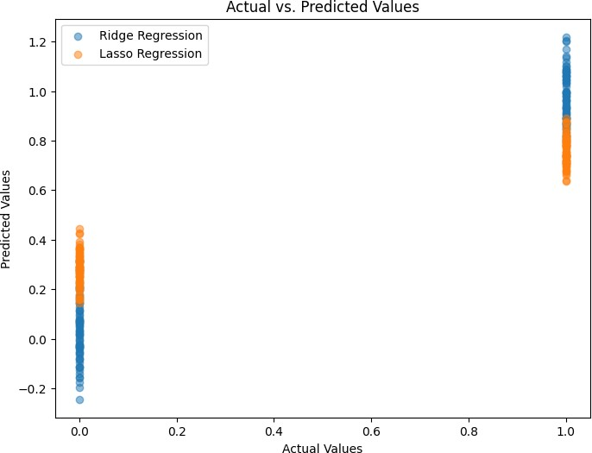

value.

## KNN-Regression

k-NN Regression Results:

Mean Squared Error: 892.9409909151974 Mean Absolute Error: 20.476592154901127 R-squared Error: 0.9412303343796538

The results for k-NN (k-Nearest Neighbors) Regression reveal the model’s performance in predicting the target variable. The Mean Squared Error (MSE) value of 892.94 indicates that, on average, the model’s predictions have a relatively high degree of error, which suggests that there may be significant variability in the predictions. The Mean Absolute Error (MAE) value of 20.48 reflects a moderate average absolute error in the model’s predictions. The R-squared value of 0.9412 is quite high, indicating that the model explains a substantial proportion of the variance in the data.

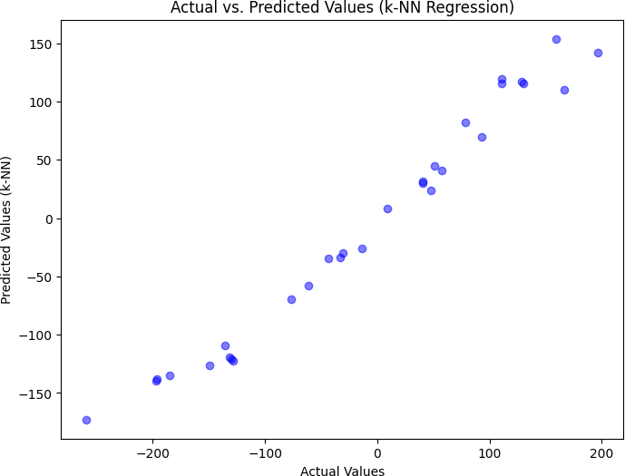

# Conclusion

In summary, the machine learning models presented in your results exhibit varying levels of performance depending on the task at hand:

Classification: - The Perceptron model demonstrates exceptional accuracy and precision for binary classification tasks, making it a robust choice when precise class separation is required. - Logistic Regression performs reliably in more complex binary classification scenarios, maintaining high accuracy and balanced precision and recall. - Both models offer valuable tools for different classification needs. Regression: - Ridge Regression outperforms other regression models with a low Mean Squared Error and a high R-squared value. It provides an excellent fit to the data and explains a substantial portion of the variance in the target variable. - Lasso Regression, while still useful in some cases, lags behind Ridge Regression, as it exhibits a higher MSE and a lower R-squared value. - k-NN Regression proves to be another strong choice for regression tasks, offering accurate predictions and explaining a

significant portion of the target variable’s variance.

In choosing the appropriate model, it is crucial to consider the specific requirements and charac- teristics of your dataset and task, as each model has its own strengths and weaknesses.

# References

1. The github link to refer the code of the dataset and the results is: [github link](https://github.com/sricharanmartha/STAT-ML-PROJECT-REVIEW-2.git)
2. This is the link to check the dataset for which i have done all the code and the entire process is: [kaggle link](https://www.kaggle.com/datasets/bhanupratapbiswas/aadhar-households-covered-under-nfsa-2013-of-mp/data)